# Scenario 1: Authenticate with System

## Scenario Description

* All functionality relating to a user signing in and having their details authenticated with the system

## Version Control

|  |  |  |  |
| --- | --- | --- | --- |
| Version # | Date | Author | Description |
| 1.0 | 20/09/2019 | Brodie Osborn | Initial Version |

## Test Scripts

The following scripts will cover this scenario:

* 1.1 Successfully sign in
* 1.2 Sign in unsuccessful (Incorrect User name)
* 1.3 Sign in unsuccessful (Incorrect Password)

## Use Case

* Authenticate with System

## Test Components/Requirements

This test scenario covers the following high-level test requirements (see scripts below for specific requirements covered by each test script):

* Ensure that users can sign in to the system with the correct login information
* Ensure that incorrect login information is properly handled

## User Groups

* All Users

## Script 1.1: Successfully Sign in

### Script Description

* A User can successfully have their details authenticated using a registered user profile

### Testing Requirements

This test script covers the following specific testing requirements:

* Ensure that a user can log in to the system using the correct login information

### Setup

* A user must exist in the system with the username [user@gmail.com](mailto:user@gmail.com) and the password “password”

### Teardown

### Script Steps

| **Step #** | **Test Action** | **Expected Results** | **Pass/ Fail** |
| --- | --- | --- | --- |
| 1 | Enter the Username [user@gmail.com](mailto:user@gmail.com) into the Username field and enter the Password “password” into the password field |  | PASS |
| 2 | Click “Login” | Authenticate user information  Display the main page for the User | PASS (see screenshot 2) |

### Test Execution

|  |  |  |  |  |
| --- | --- | --- | --- | --- |
| Date/Time | Tester | Test ID | Test Phase | Status |
| 23/09/2019 | Brodie Osborn | #1 | IOCM | Complete |

## Script 1.2: Sign in Unsuccessful (Incorrect Password)

### Script Description

* A User cannot login if they enter the incorrect username or password

### Testing Requirements

This test script covers the following specific testing requirements:

* Ensure that the system can correctly identify if a user is entering incorrect login information

### Setup

* A user must exist in the system with the username [user@gmail.com](mailto:user@gmail.com) and the password “password”

### Teardown

### Script Steps

| **Step #** | **Test Action** | **Expected Results** | **Pass/ Fail** |
| --- | --- | --- | --- |
| 1 | Enter the Username [user@gmail.com](mailto:user@gmail.com) into the Username field and enter the Password “incorrect” into the password field |  | PASS |
| 2 | Click “Login” | Authenticate user information  Display the login failed message to the user | PASS (see screenshot 3) |

### Test Execution

|  |  |  |  |  |
| --- | --- | --- | --- | --- |
| Date/Time | Tester | Test ID | Test Phase | Status |
| 23/09/2019 | Brodie Osborn | #1 | IOCM | Complete |

## Script 1.3: Sign in Unsuccessful (Incorrect Username)

### Script Description

* A User cannot login if they enter the incorrect username or password

### Testing Requirements

This test script covers the following specific testing requirements:

* Ensure that the system can correctly identify if a user is entering incorrect login information

### Setup

* A user must exist in the system with the username [user@gmail.com](mailto:user@gmail.com) and the password “password”

### Teardown

### Script Steps

| **Step #** | **Test Action** | **Expected Results** | **Pass/ Fail** |
| --- | --- | --- | --- |
| 1 | Enter the Username [jimmy95@gmail.com](mailto:jimmy95@gmail.com) into the Username field and enter the Password “password” into the password field |  | PASS |
| 2 | Click “Login” | Authenticate user information  Display the login failed message to the user | PASS |

### Test Execution

|  |  |  |  |  |
| --- | --- | --- | --- | --- |
| Date/Time | Tester | Test ID | Test Phase | Status |
| 23/09/2019 | Brodie Osborn | #1 | IOCM | Complete |

**Screenshot 1**

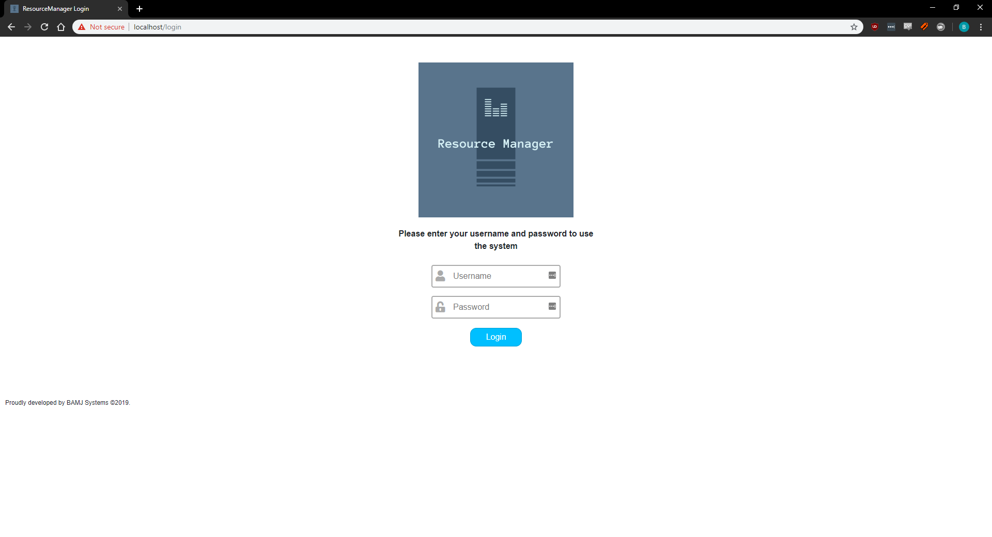

**Screenshot 2**

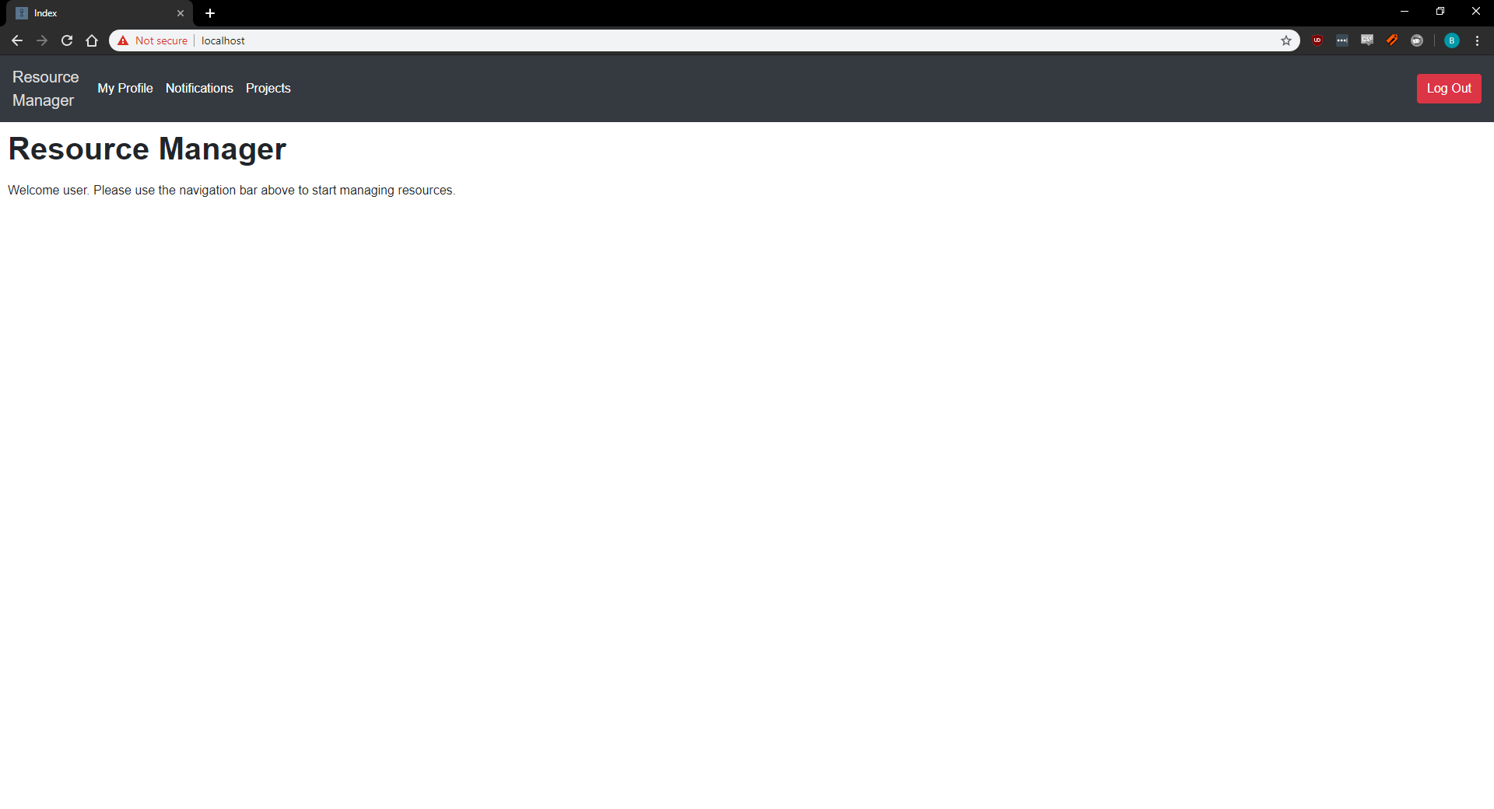

**Screenshot 3**

